

**Project Report**

**Real Estate Agency**

**Submitted By:**

* Malik Aliyan Zawar, Roll No: 2025-CS-166
* Muhammad Hamza Qamar, Roll No: 2025-CS-123
* Saad Mahmood, Roll No: 2025-CS-120
* Muhammad Abdullah Siddique, Roll No: 2025-CS-130
* Muhammad Sheharyar, Roll No: 2025-CS-154
* Abdul Hannan, Roll No: 2025-CS-121

**Course:** AICT-Lab

**Instructor: mISS ramsha khalid**

**Date:** 08-01-2026

Department of Computer Science

University of Engineering and Technology Lahore

Contents

**1. Executive Summary** 3

**2. Project Objectives & Scope** 3

Objectives 3

Scope 4

**3. Site Structure & Navigation** 4

Navigation Bar 4

Home Page 4

About Us Page 6

Properties Page 8

Service Page 10

Contact Us Page 12

**4. Design Choices** 13

Colour Theory & Brand Identity 13

Typography 13

Advanced Layout Techniques 13

Responsiveness & Availability 14

User Interactivity 14

**5. Assets Used** 14

Visual Assets (Images & Media) 14

Data Sources & Documentation 15

External Web Pages 15

Development & Deployment tools 15

**6. Website Publishing** 15

**7. LinkedIn Posting** 16

**8. Reflection** 16

Learning Outcomes 16

Improvements 16

**Introduction**

The Real Estate Agency Website project is designed to create a **professional and easy-to-use website** for a real estate business. The website shows **property listings, agency services, and company information** in a clear and organized way. It is built using **HTML and CSS** and focuses only on **front-end design**, without any backend or database features. The website has **five main pages**—Home, About, Services, Properties, and Contact—with a consistent **navigation menu** for easy browsing. The design uses **clean layouts, soft colours, and readable fonts**, while images from our system make the site visually attractive. It is also **responsive**, working well on computers, tablets, and phones. This project helps in learning **HTML** and **CSS**, and providing practical experience in creating a website for a real estate agency.

# **1. Executive Summary**

This report presents a detailed overview of the website project developed using the provided website files. The website is designed as a multi-page informational platform that focuses on presenting property-related information and services in a clear and organized manner. The main aim of the website is to provide users with easy access to information through a simple and user-friendly interface. The website includes several pages such as Home, About, Properties, Services, and Contact, with each page serving a specific purpose. The Home page introduces the website and provides an overview of its content, while the About page explains the background and purpose of the website. The Properties page displays property-related information in a structured format, and the Services page highlights the services offered. The Contact page provides essential contact details for user communication. Consistent design and layout are maintained across all pages using CSS to ensure a professional and uniform appearance. Clear and simple navigation allows users to move easily between different sections of the website. This report also explains the design choices, assets used, and the process of running or publishing the website. Overall, the project helped in developing a better understanding of website structure, page organization, styling with CSS, and basic web development practices.

# **2. Project Objectives & Scope**

### Objectives

The objectives of this project are as follow;

* To create a simple and informative website related to properties and services.
* The website is designed to help users easily understand the information provided on different pages.
* To make the website easy to use, with clear navigation so users can move from one page to another without confusion.
* The project also aims to practice basic web development skills by using HTML to create web pages and CSS to design and style them in a consistent way.

### Scope

The scope of this project is to develop a website consisting of five main pages: Home, About, Properties, Services, and Contact. Each page is designed to present information related to properties and services in a clear and organized way. The project focuses on creating a well-structured layout and ensuring smooth navigation between all pages. Basic web technologies such as HTML and CSS are used to design and style the website.

# **3. Site Structure & Navigation**

### Navigation Bar

The website has a navigation bar at the top of every page to help users move between different sections of website easily. The navigation bar includes the main pages: **HOME, ABOUT US, PROPERTIES, SERVICES, and CONTACT.** It is designed to be clear and easy to read, with contrasting text colours for visibility. The navigation bar stays consistent across all pages, making it simple for visitors to explore the website. Its placement at the top ensures that it is always visible and accessible when browsing**.** The website is organized into five main pages to ensure clear structure and easy navigation. A consistent navigation menu is used across all pages, allowing users to move smoothly from one section to another without confusion.

Each page serves a specific purpose, as described below:

### Home Page

The Home page serves as the main entry point of the website. It provides an overview of the website and helps users understand its purpose at first glance. Here are some **Screenshots of the Home page** from our website.

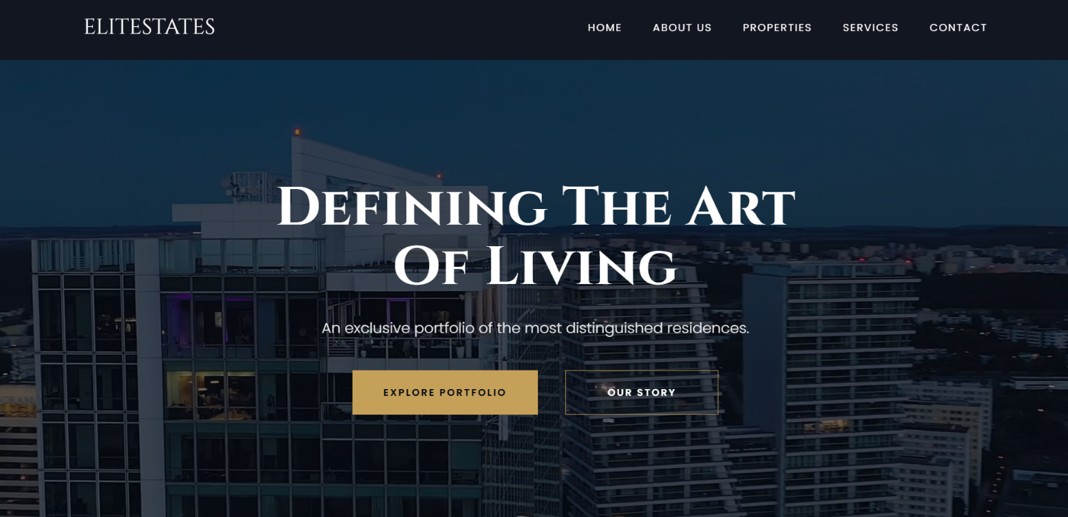

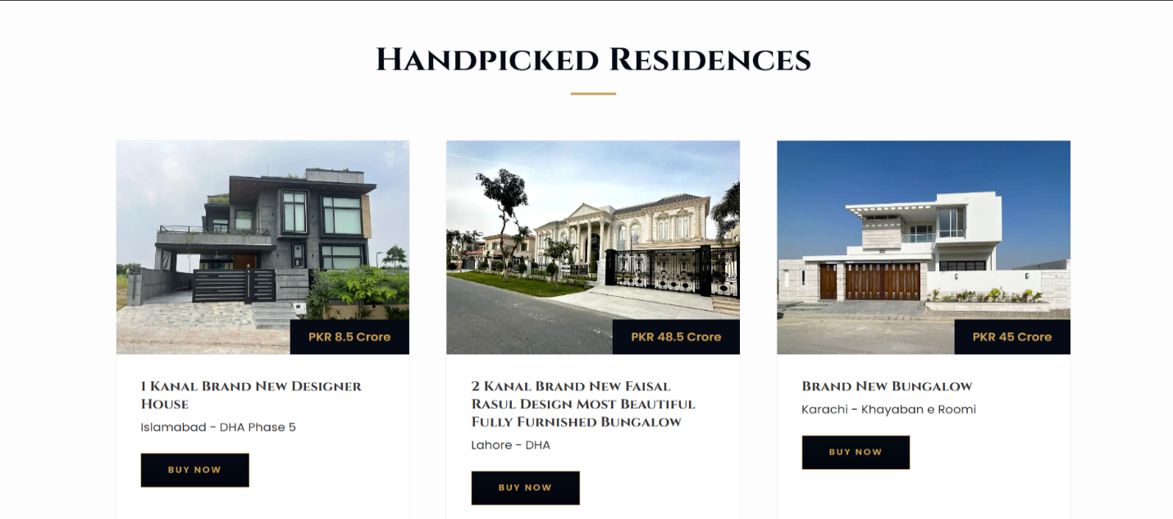

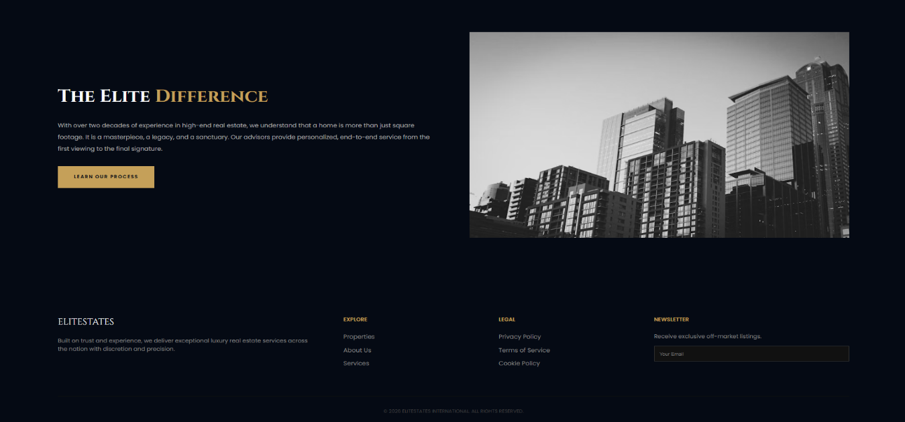**\**

### About Us Page

The About Us page of the website. It provides users with a clear understanding of what the website is about. It also gives some introduction about our team. Here are some **Screenshots of the About Us page** from our website.

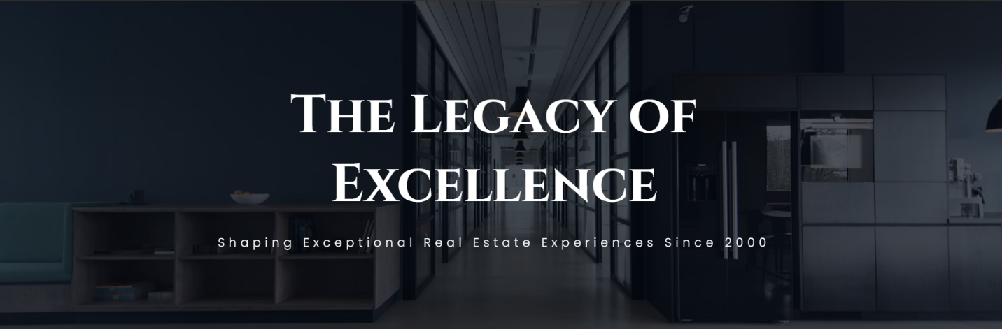

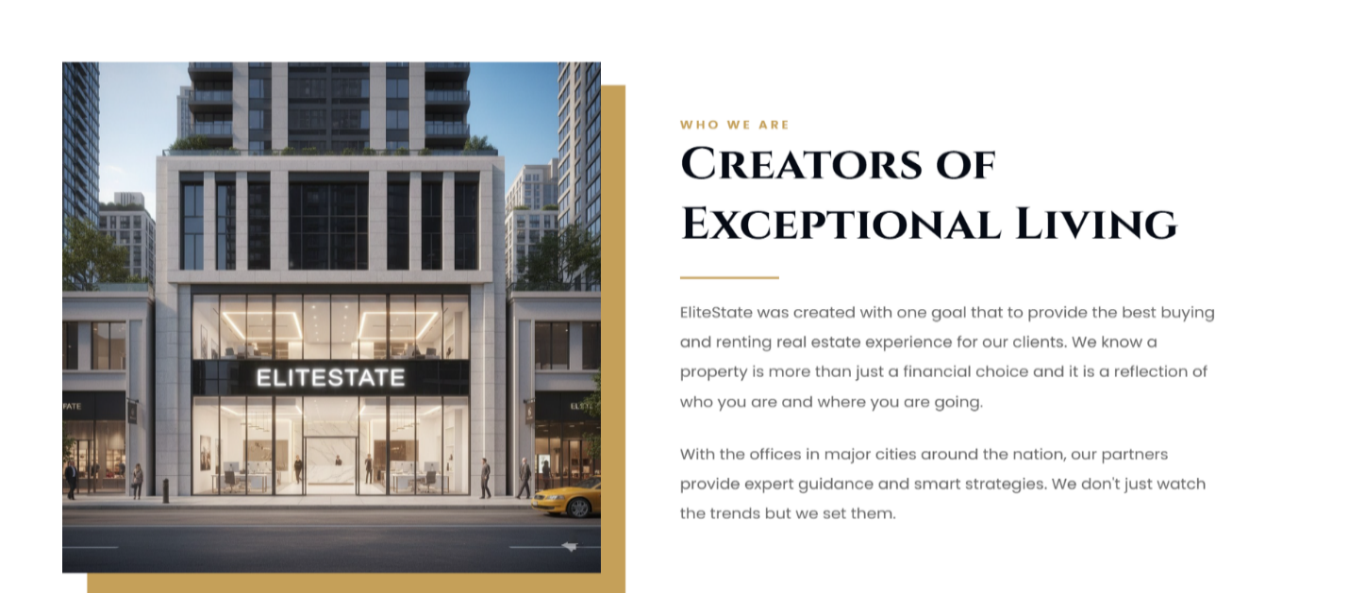

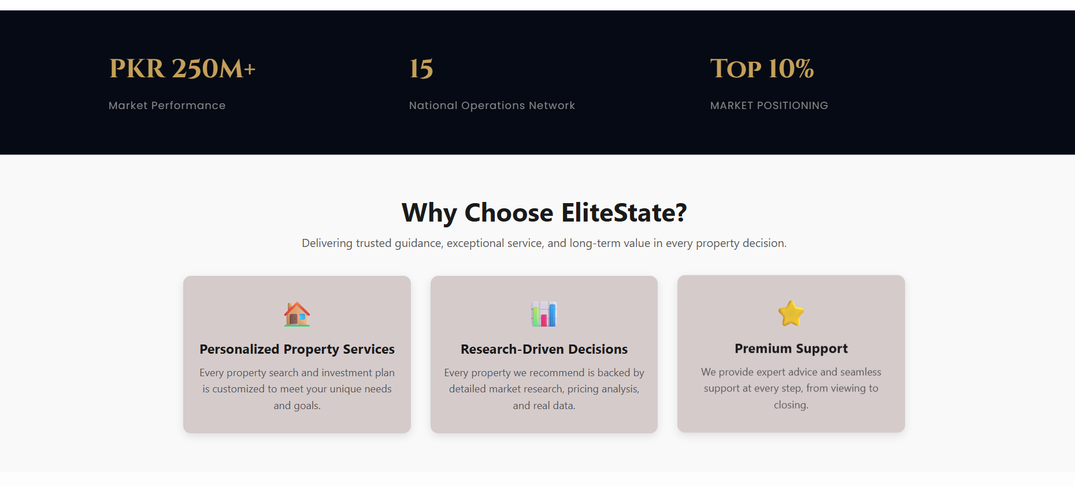



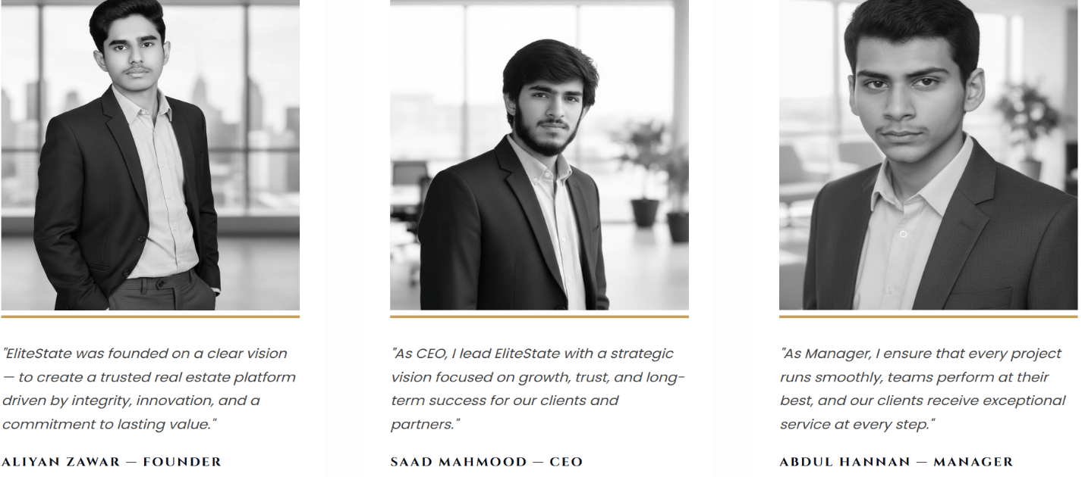

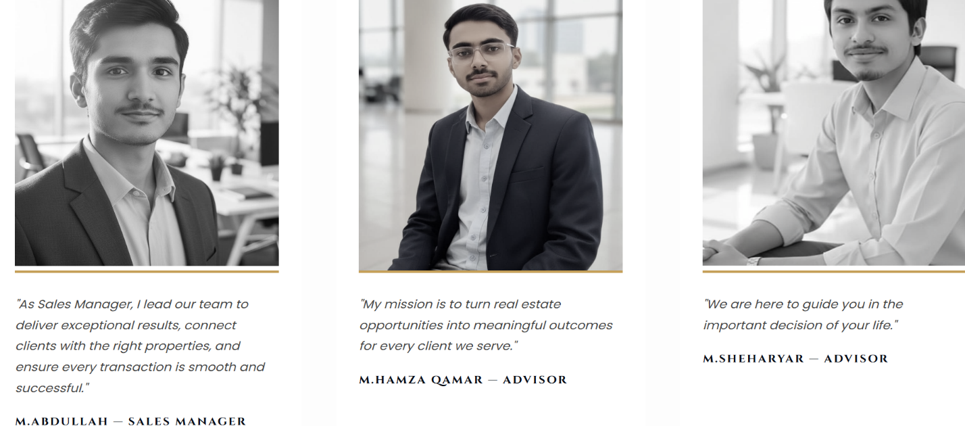

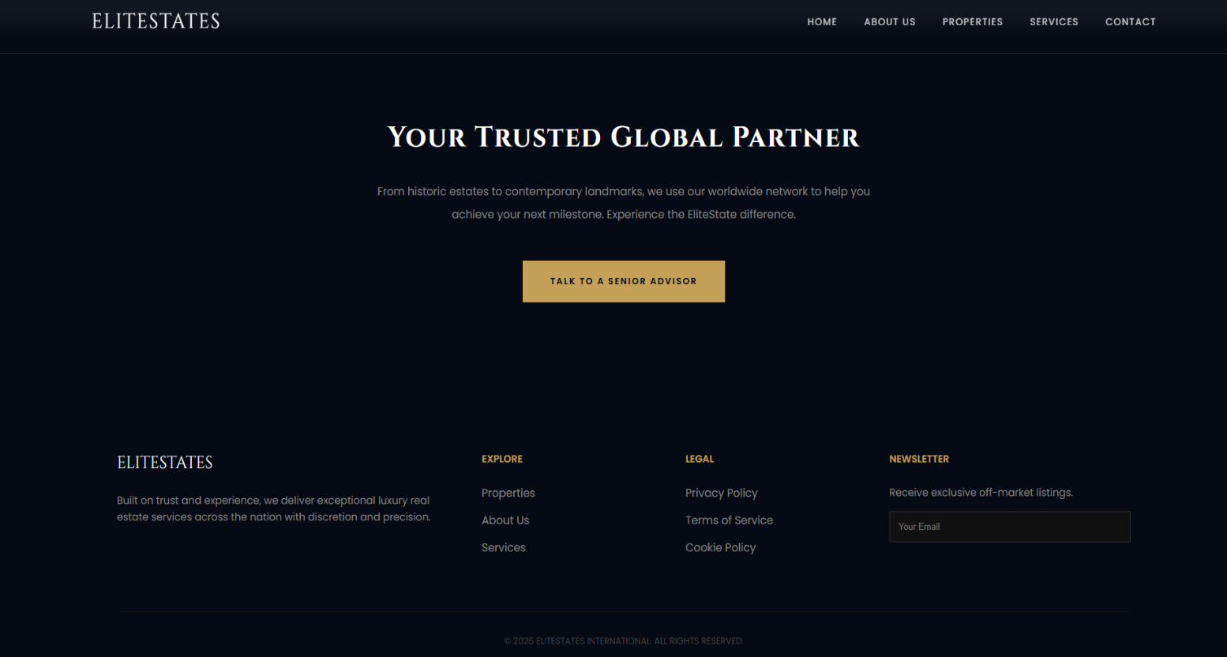

### Properties Page

The Properties page presents information related to available properties in a clear and organized format. It allows users to view property details easily. It shows the user that which property is on sale or rent. There are three sections in the properties page in which first section shows the All properties and the second section shows the properties for sale and the third section shows the properties on the rent. Here are some **Screenshots of the properties page** from our website.

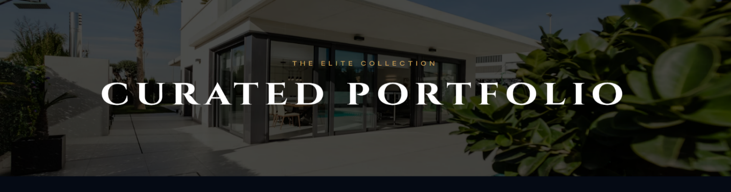

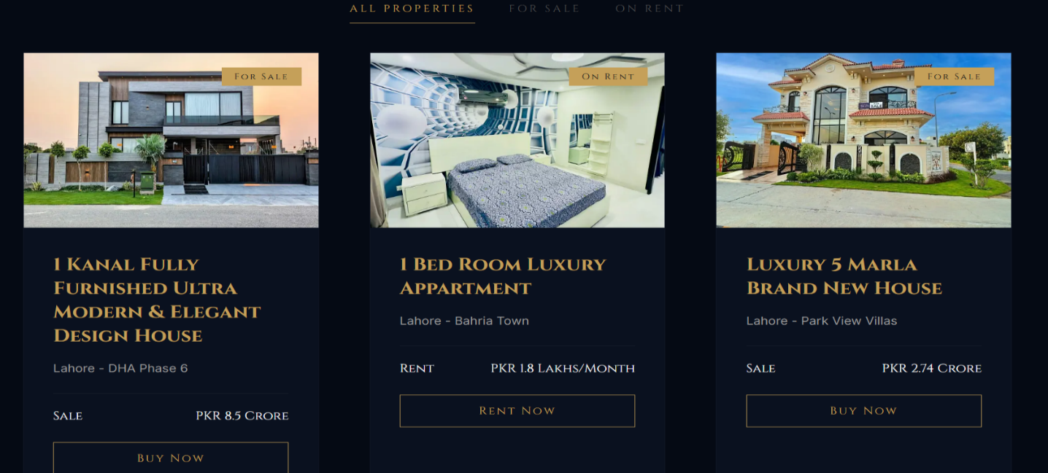

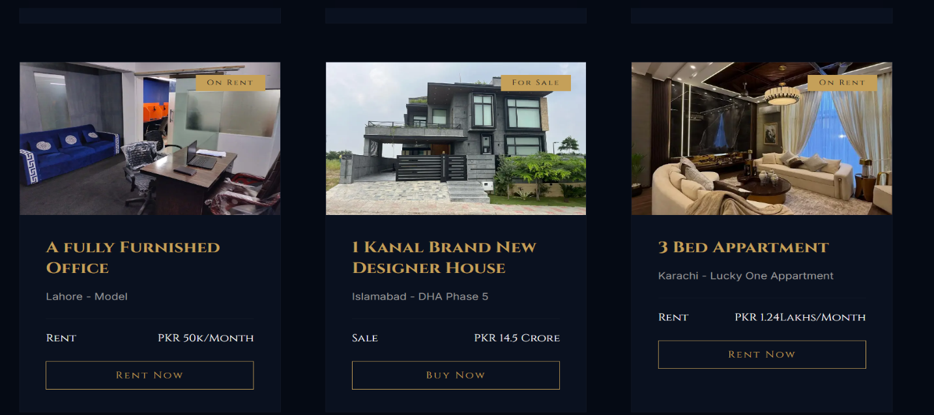

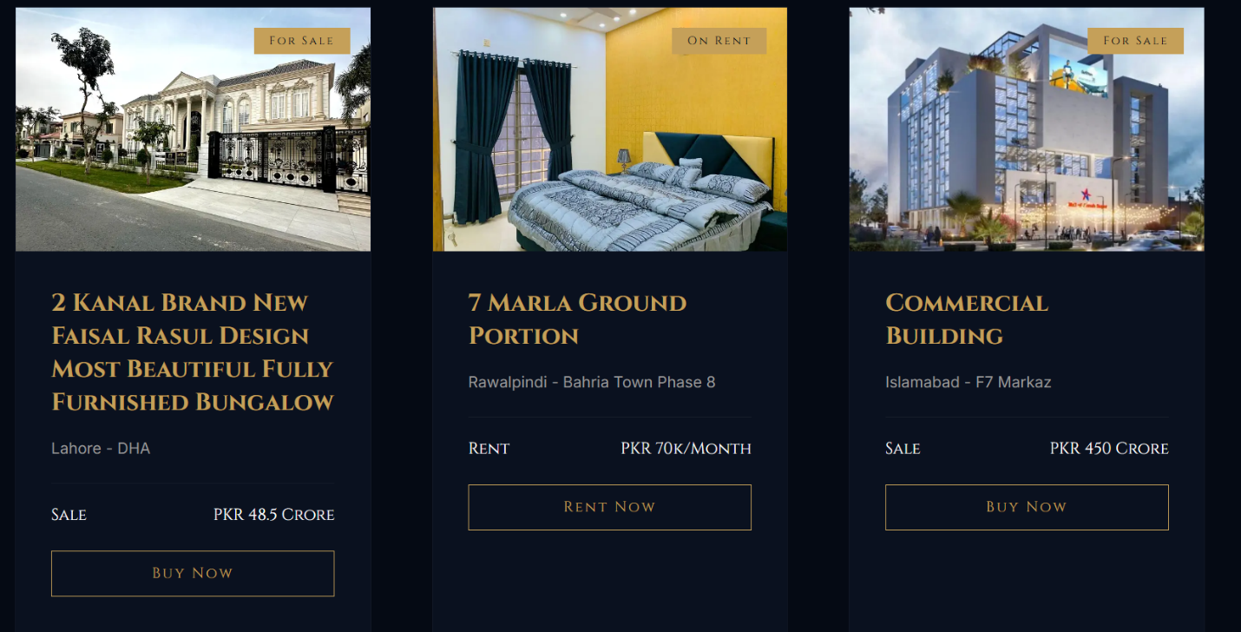

\

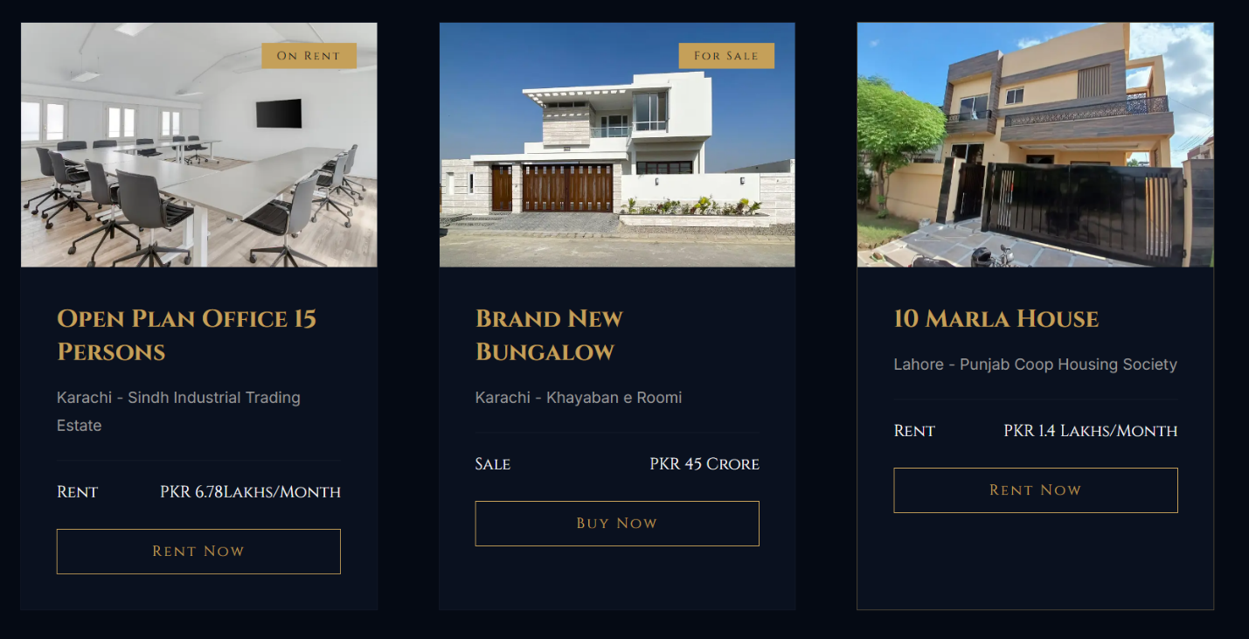

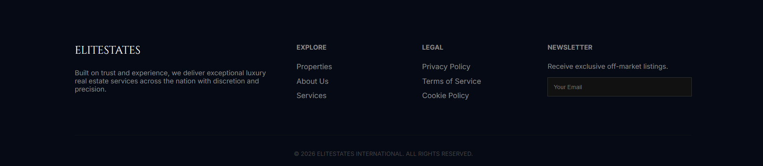

### Service Page

The Services page outlines the services offered. It helps users understand what services are available and how they relate to the properties. It also tells the user about our strategies. Finding the right property can be hard ELITESTAE does this for users. It’s like their Smart Investment for future. All the deals are done after all legal checks to ensure future safety for customers.

Here are some **Screenshots of the services page** from our website.

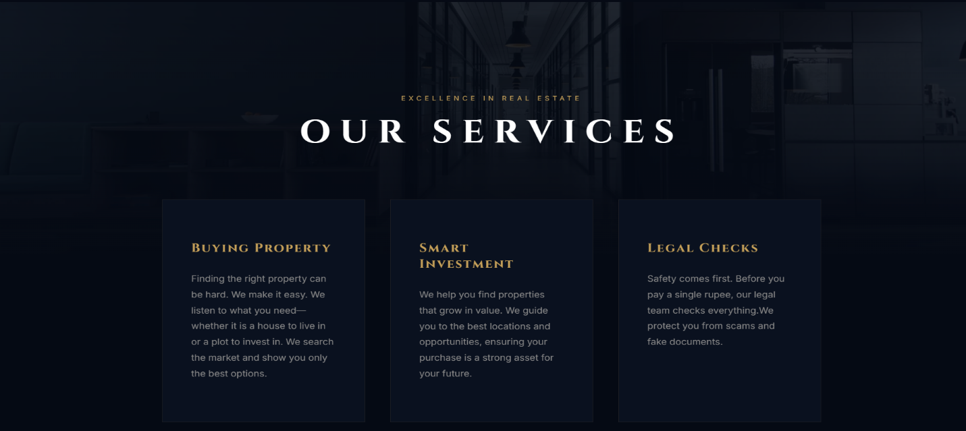

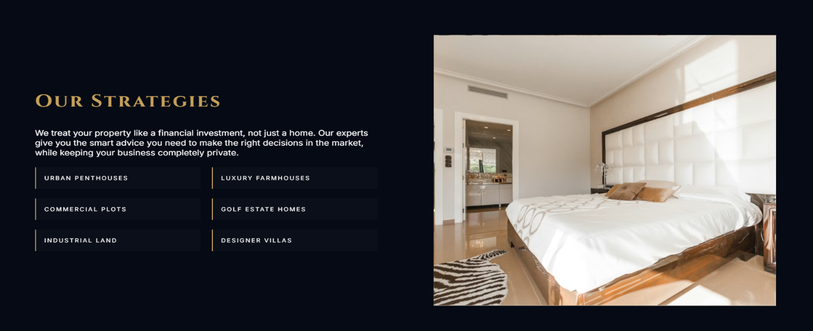

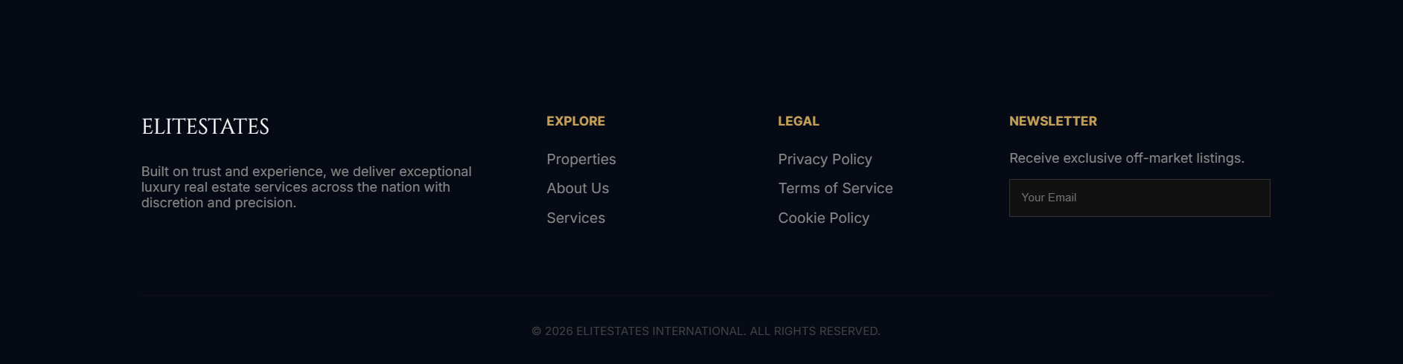

### Contact Us Page

The Contact Us page provides essential contact information, allowing users to reach out easily for inquiries or further information. It also provides the different offices number across the nation. There is a section where the client can write his name and the subject and gives us message. Here are some **Screenshots of the contact page** from our website.



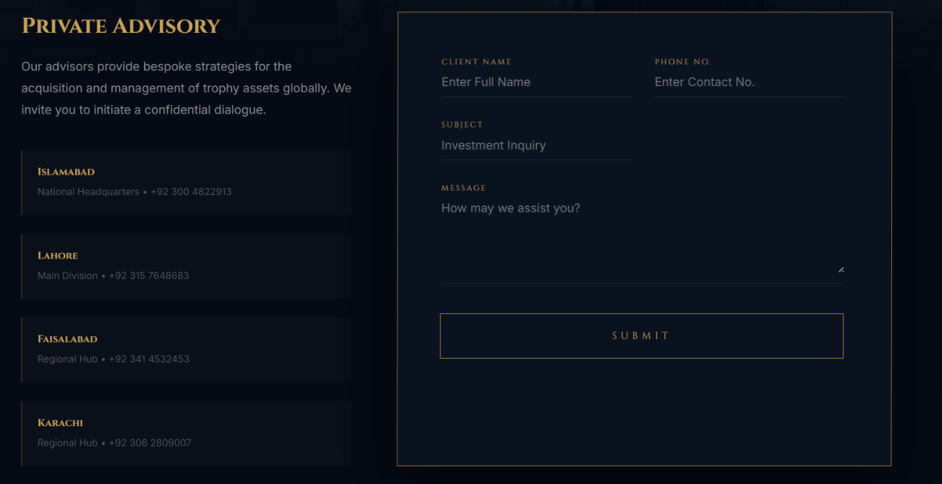

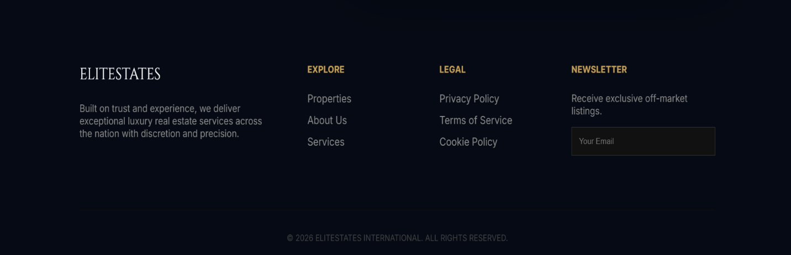

# **4. Design Choices**

The design of the **Elite States website** was strategically developed to establish a high end, luxury brand identity. The following choices were made to ensure a professional and cohesive user experience across all five pages:

### Colour Theory & Brand Identity

* + **The “Elite” Palette:** We utilized a "Dark Luxury" theme. The primary background colour across the site is a deep navy-black (#050a14), which creates a sense of exclusivity.
  + **Gold Accents:** To signify prestige, we used a signature gold colour (#c5a059) for the logo, call-to-action buttons, and spans. This creates a high-contrast, premium look against the dark background.
  + **Glass morphism:** The navigation bar uses a modern "Glass morphism" effect. By setting background: RGBA (5, 10, 20, 0.95) and backdrop-filter: blur(10px), the menu feels integrated into the background while remaining highly readable.

### Typography

* + **Serif Headings:** We imported the “**Cinzel”** Google Font specifically for the logo and main headers. This serif font gives the brand a classic, established, and "Elite" feel.
  + **Sans-Serif Body:** For the main content and descriptions, we used **Poppins** and **Inter**. These were chosen for their clean, modern aesthetic and high legibility on digital screens.

### Advanced Layout Techniques

* + **CSS Flexbox:** We used Flexbox for the nav and footer elements to ensure precise alignment and even distribution of links across the screen.
  + **CSS Grid:** The "Properties" listing page and the "Services" layout utilize CSS Grid. This allowed us to create a structured multi-column display that organizes complex property data into a clean, easy-to-digest format.
  + **3D Perspective:** A unique technical choice was the use of the perspective property (set to 1500px or 2000px) on the body and sections. This adds a subtle sense of depth to the page as users scroll through the content.

### Responsiveness & Availability

* + **Fluid Media Queries:** We implemented responsive breakpoints at 900px and 480px. On tablets and phones, the layout shifts from a horizontal grid to a single-column stack to ensure usability on all devices.
  + **Interactive Mobile Menu:** We built a functional "Hamburger" menu using a hidden checkbox (#menu-toggle) and CSS logic. This allows mobile users to toggle the navigation without requiring heavy JavaScript, keeping the site fast and efficient.

### User Interactivity

* + **Cubic-Bezier Animations:** Rather than standard fades, we used custom timing functions (Cubic-Bezier (0.19, 1, 0.22, 1)) for transitions. This makes the hover effects and property card entrances feel "snappy" and high-end.
  + **CSS-Only Filtering:** On the properties page, we utilized radio buttons (#all, #sale, #rent) to allow users to filter listings. This showcases an advanced use of CSS selectors (:checked ~ .property-grid) to create a functional user interface.

# **5. Assets Used**

This section details the various external and internal resources utilized to build the **Elite Homes** International digital platform, ensuring a high-end visual experience and data-driven content.

### Visual Assets (Images & Media)

* + **Dynamic Hero Media:** A high-definition background video (index-bg.mp4) was used for the primary landing page. This serves as a "visual hook" to establish the luxury brand identity immediately upon page load.
  + **Property Photographs:** High-resolution imagery for property listings was sourced to showcase estates on the "Properties" page. These images were optimized for web performance while maintaining clarity.
  + **Scalable Vector Graphics (SVG):** To ensure crisp UI elements at any zoom level, SVGs were used for the navigation system, specifically the three-lines-menu-“svgrepo-com.svg ” for the mobile responsive menu.
  + **Branding Icons:** Custom favicon and logo assets were integrated to maintain a consistent brand presence across the browser tab and the website header.

### Data Sources & Documentation

* + **Microsoft Excel Data:** Quantitative data, including property valuations, square footage, and availability status, was managed in an Excel workbook. This data served as the "Single Source of Truth" for the information displayed on the website.
  + **Content Copy:** The textual content for the "About" and "Services" pages was drafted specifically for this project to reflect a professional real estate agency's tone and strategy.

### External Web Pages

* + **Google Fonts API:** The project utilizes the Google Fonts library to dynamically load the following typefaces:
    - * **Cinzel:** Used for the logo and primary headings to provide a classic, elite aesthetic.
      * **Poppins / Inter:** Used for body text and navigation to ensure modern readability across all devices.
    - **CSS Design Systems:** The layout was built using modern CSS standards, including Flexbox for alignment and CSS Grid for complex property displays, avoiding the need for heavy external frameworks like Bootstrap.

### Development & Deployment tools

* + - **GitHub:** Used as the version control system to track changes across the HTML and CSS files.
    - **GitHub Pages:** Served as the hosting platform to transition the project from a local development environment to a live, public URL.

# **6. Website Publishing**

* **GitHub Repository:**
  + - [**https://github.com/AICT-LAB-PROJECT/AICT-Final-Project.git**](https://github.com/AICT-LAB-PROJECT/AICT-Final-Project.git)
* **GitHub Pages:**
  + - [**https://github.com/AICT-LAB-PROJECT/AICT-Final-Project.git**](https://github.com/AICT-LAB-PROJECT/AICT-Final-Project.git)
  + **Netlify:** 
    - [**https://elite-state.netlify.app/**](https://elite-state.netlify.app/)

# **7. LinkedIn Posting**

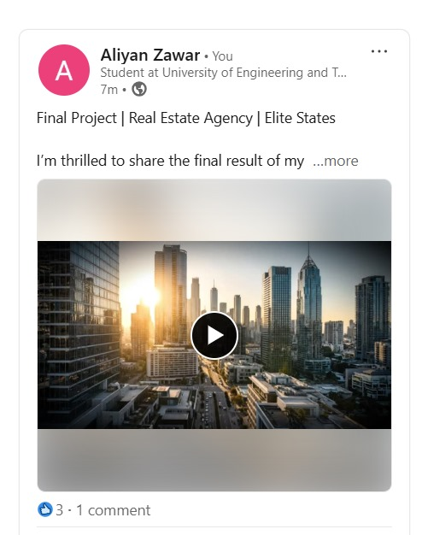Our Team uploaded a video on **LinkedIn** demonstrating our project. Here is the screenshot of the LinkedInpost:

# **8. Reflection**

### Learning Outcomes

* Learned how to create a multi-page website using HTML and CSS.
* Understood how to link web pages using navigation menus.
* Learned how to structure web content in a proper and organized way.
* Gained experience in using fonts, images, and colours.
* Learned how to design a clean and professional website layout.
* Improved understanding of basic front-end web development concepts.

### Improvements

* The website can be made more responsive for different screen sizes.
* More features can be added to improve user interaction.
* Better styling and layout enhancements can be applied.
* The overall user experience can be further improved.